Imagine no load shedding, it’s easy if you try – no hell below us, above us only sky

Introduction & Background
The publication of the list of preferred bidders for the Risk Mitigation IPP Procurement Programme (RMIPPPP) and the subsequent opening of bid window 5 by the Department of Mineral Resources and Energy (DMRE) has focused attention on the accelerated construction of renewable energy generation in South Africa. This brings the procurement of renewable energy from bid window 1 to bid window 5 to a total of 9 GW, with a further procurement of 1.8 GW from the RMIPPPP. Although this may not be as much as civil society groups, industry associations, research organisations and even Eskom may have wanted, the total of 10.8 GW renewable energy, i.e. 24% of capacity currently installed in South Africa, does suggest that South Africa may well be catching up with the rest of the world that is transitioning fast into a renewable-based energy future.
The establishment of the Presidential Climate Change Coordinating Commission (P4C), with a clear mandate inherited from the National Planning Commission’s Just Transition Scenarios, will inevitably lead to Government confirming the globally accepted Net Zero Target referred to in the Low Emissions Development Strategy approved by Cabinet in September 2020, and mentioned in the Intended Nationally Determined Contribution (INDC). The strongest commitment statement to date to the energy transition comes from the Presidential Economic Advisory Council (PEAC): “What used to be a choice is now mandatory. Those countries not adapting to a green transition will find themselves behind and excluded.”

The above developments undoubtedly need to be celebrated. According to the Council for Scientific and Industrial Research (CSIR) an ambitious commitment to building 5 GW of renewable energy per annum, which equates the generating capacity of two-and-a-half Koeberg nuclear power stations, to replace South Africa’s ageing coal-fired power stations could unlock nearly R500 billion worth of investment over the next ten years, and create 50 000 jobs per annum. This, in turn, would trigger an upstream industrialization programme that will catalyse the re-industrialisation of the South African economy that will rapidly drive down unemployment levels. All good news. Expanding and decarbonizing the generation capacity through investment in renewable energy, however, represents only one aspect of the transition to a stable and sustainable energy scenario.

Once generated, electricity must be transmitted from distributed generation sites to load centers via the electricity grid. The existing grid is unevenly developed – it is strong in the north east where the coal deposits are, and weak in the south west where the wind and solar resources are the best. Is the national grid fit-for-purpose? The national demand profile is variable, with strong daily and seasonal cycles. While wind farms at two different locations might generate the same amount of energy per year, the times during which they dispatch energy onto the grid may differ drastically. One wind farm may generate power when the grid needs it, e.g. during the morning and evening peak times in winter. How well will the renewable energy generation synchronize with the demand patterns? Investments in renewable energy will unlock economic growth, especially in the regions where the plants and grid infrastructure are sited However, will these benefits be optimally and equitably distributed across the South African landscape? Communities around wind and solar farms are well positioned to benefit developmentally from these projects. But this depends on the capabilities of local governments, local business and civil society to take advantage of new inward investment flows. This has implications for the location of projects. It would not be desirable, for example, to put projects into locations where there are high levels of corruption.

Research Questions & Current Scenario
Addressing these questions in the medium- to long-term requires careful consideration of the geographical distribution of future renewable generation capacity. In this context, there are three core strategic questions that need to be addressed: Firstly, in the short- to medium-term, i.e. 1 to 5 years, where should wind and solar farms be located to ensure reliable electricity generation and transmission at lowest cost? Secondly, from a medium- to longer-term perspective, i.e. 5 to 15 years, where should the wind and solar farms be located to ensure integrated bulk procurement of renewable energy generation that optimally supports the changing electricity demand over time? And thirdly, where should wind and solar farms be located to ensure maximum developmental impacts with respect to jobs, local economies and manufacturing? These questions, and the associated challenges, are currently addressed by a range of stake-holders, including regulatory entities such as the National Energy Regulator of South Africa (NERSA) and the Department of Mineral Resources and Energy (DMRE), the national System Operator (SO) Eskom, and research institutions such as the CSIR, and the Centre for Renewable and Sustainable Energy Studies (CRSES) and Centre for Sustainability Transitions (CST) at Stellenbosch University.

At the moment, the Independent Power Producers Office (IPPO) evaluates bids from private developers mostly according to price of electricity generated (R/kWh), with limited reference to where each these wind and solar farms should be located. In 2015, as part of phase 1 of the Strategic Environmental Assessment (SEA) study for wind and solar PV, the CSIR proposed a total of eight Renewable Energy Development Zones (REDZs) for fast-tracking the deployment of future wind and solar PV plants. These REDZs, proclaimed by the Department of Environmental affairs (DEA), currently known as the Department of Forestry, Fisheries and the Environment (DFFE), demarcate areas with good grid connection infrastructure where large-scale wind and solar PV facilities can be developed with limited negative impacts on the environment, whilst delivering equitable socio-economic benefits to regional communities. In 2019, as part of phase 2 of the SEA study, the CSIR proposed three additional REDZ, bringing the total number of REDZs to eleven. The proclamation of these REDZs represents the first major step towards addressing questions on the siting of renewable energy plants.
Fig. 1 and Fig. 2 map the locations of the REDZs against the wind and solar PV resources of South Africa. It is clear that the REDZs exhibit excellent and diverse wind and solar PV energy resources. REDZs in the Southern regions such as Cookhouse, Stormberg, Beaufort-West, Komsberg and Overberg show good wind generation potential. REDZs such as Springbok, Upington, Kimberley, Vryburg, Klerksdorp and Emalahleni show good solar PV potential. Fig. 3 shows the locations of the REIPPPP wind and solar PV projects up to bid window 4. It is clear that there is ample scope for extending the penetration of wind and solar PV energy in most of the REDZs.
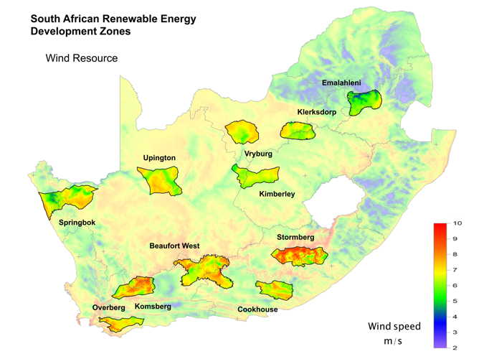 | 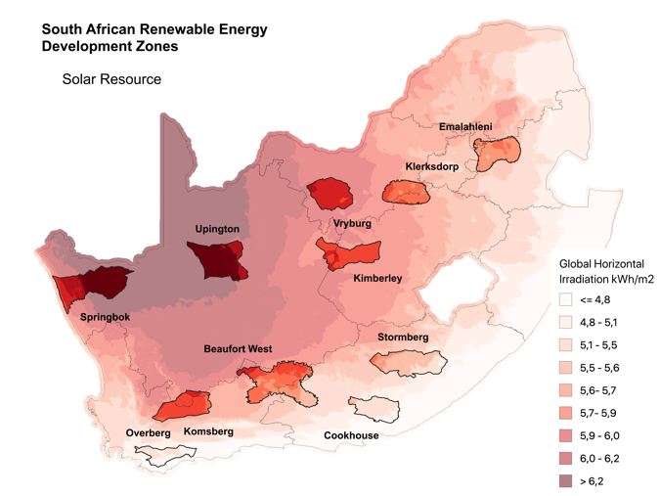
Figure 1: Wind speed map of South Africa and within REDZs. | Figure 2: Annual global horizontal irradiation map of South Africa and within REDZs.

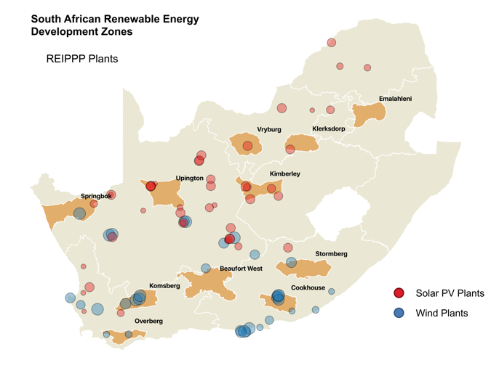
Figure 3: REIPPPP wind and solar PV projects.

Grid Readiness
Fig. 4 shows the power stations and Main Transmission System (MTS) of associated with the national grid. The bulk of the generation, i.e. coal-fired stations, are located in the North East of South Africa, mainly Mpumalanga. This is also, therefore, where the grid capacity is the most well-developed and robust. However, if at least 27 GW of renewable energy is to be constructed in the next 10 years, the bulk of that will have to be built in the regions with the best wind and solar PV resources, namely the Southern and Central regions of the country. These are the regions where grid capacity is arguably the weakest. This transition will, in short, result in a 180 degree spatial swing from the traditional energy generation heartland to the South-Western, South-Eastern and Central regions of the country where the wind and solar resources are considerable, but the grid infrastructure is limited. The electricity transmission zones and MTS substations mapped in Fig. 5, however, show that the REDZs are well aligned with the existing grid infrastructure.

It is estimated that the overall cost to upgrade and re-orient the grid to prepare for renewables in the short-term will be about R20 billion. While this represents a fraction of the total capital cost of the energy transition through to net zero by 2050, it is nevertheless a key investment. Internationally, grid readiness investments amount on average from 5% to 10% of the total capital costs. A capital cost investment of R500 billion in renewable energy over the next decade would require at least R25 billion for grid readiness. The Generation Connection Capacity Assessment of the 2022 Transmission Network (GCCA-2022) produced by Eskom represents a good departure point for future developments in grid readiness.

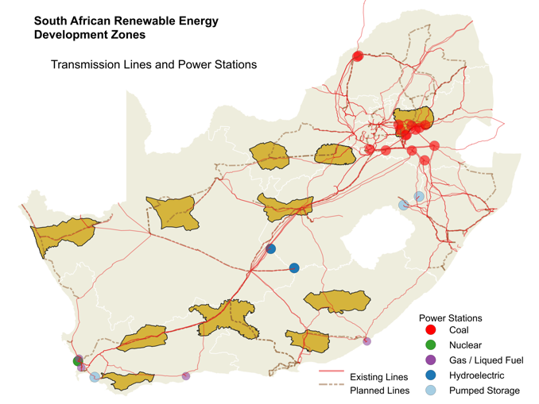 | 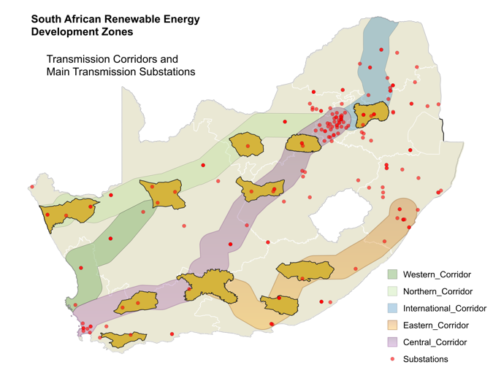
Figure 4: Existing thermal and hydro power stations and transmission infrastructure. | Figure 5: Transmission corridors and main transmission substations.

Demand Profile & Generation profile
The second question focusses on the impacts of a high penetration of variable renewable energy generation on grid operations. In this context, it is of interest to consider whether the future renewable energy fleet can be deployed such that the demand profile is optimally supported despite the influences of weather and climatic conditions on power generation. Risk mitigation, whereby the risk of severe loss of generation due to extreme weather events can be minimized, represents a further aspect of interest that should inform the siting and dispersion of future renewable energy plants. The importance of these issues is recognized in the wind and solar PV resource aggregation study for South Africa conducted by the CSIR.

The temporal shapes of wind generation profiles vary with geographical location and terrain topology. Fig. 6 shows a map where geographical coordinates from the Wind Map of South Africa (WASA)⁶ are clustered according to the similarity of the average daily wind power profiles. Fig. 7 shows a similar map for the Springbok REDZ. The mean daily power generation profiles for the different clusters shown in Fig. 6 for the low and high demand seasons are shown in Fig. 8, along with the average daily national demand profile. It is clear that the wind profiles for the different geographical regions align differently with demand profile, and this alignment varies with season. The wind power profiles associated with cluster 5 in the Stormberg and Cookhouse REDZs, for instance, show a high mean and excellent correlation with the demand profile for the high demand season, but exhibits weaker performance during the low demand season. It is also noticeable that wind generation does not support the demand profile well during the morning peak period in the low demand season, and neither will solar PV generation. Overall, however, it is possible to optimize the locations and dispersion of future wind and solar PV plants such that grid support is optimized and the residual load, i.e. the difference between renewable energy generation and demand, is minimized.

The present penetration of wind and solar PV energy represents less than 10% of the energy on the South African grid. This is relatively easily managed. When penetration rises to 30% or more by 2030, grid management becomes much more complex. This may for example require the system operator to predict how much renewable energy will be generated in the hours and days ahead in order to make decisions on which non-renewable power plants to start, stop and maintain to ensure the grid meets demand across all regions on a 24/7 basis. Siting future solar and wind farms such that renewable energy generation aligns optimally with the national electricity demand, will make things much easier for the system operator (which is currently located within Eskom). Furthermore, by aligning renewable energy generation with actual daily demand patterns, the capacity of non-renewable power plants required to meet the demand can be minimized.
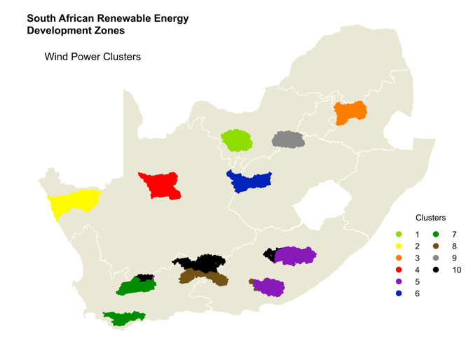 | 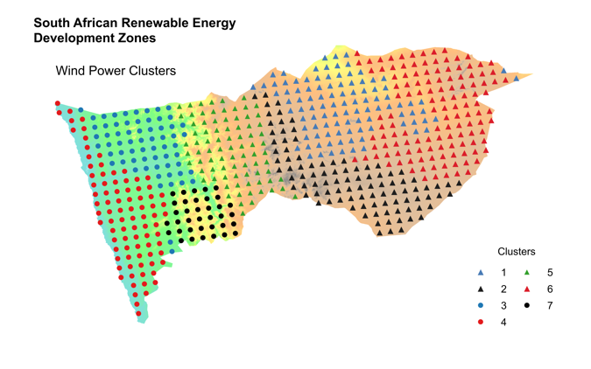
Figure 6: Wind power clusters for all REDZs. | Figure 7: Wind power clusters for the Springbok REDZ.

Figure 8: Average daily demand profile and wind power profiles for the clusters shown in Fig. 6 during high and low demand seasons.

Socio-Economic Impacts
The third question is about the just transition - the socio-economic impacts of solar and wind farms. South Africa has one of the most sophisticated systems for ensuring that local economies benefit from investments in renewables and local manufacturing benefits from local content rules. To build a renewable energy plant, regulations prescribe that a percentage of turnover and profits must be spent within the local area. As a result, the total socio-economic development spend since 2011 amounts to R1.3 billion in local communities. Spending on local content by June 2018 was R42.1 billion and 55 217 jobs were created to construct just over 5 GW of installed capacity. This is impressive, but a fraction of what is to come. Imagine the developmental impact of 5 GW PER ANNUM!! This could be SA’s biggest developmental and industrial investment since 1994. However, that is only part of the story.
The other part of the story is the impact on manufacturing and services businesses who will benefit from local content requirements (LCR) and servicing contracts (transport, repairs & maintenance, etc). LCRs are strict regulations that force developers to procure up to 60% of total infrastructure built from local companies. Imagine R50 billion a year building solar and wind farms, with at least half spent locally to buy components, turbines, blades, solar panel, electronic gadgets, transport services, repair and maintenance services, etc. Western Cape wind turbine developer, IWECON, claims that 2.5 MW turbines can be built with 80% of all inputs sourced within South Africa. Where the solar and wind farms are located could affect, therefore, not just the local economies where these infrastructures are located, but also industrial and service sector value chains. The key strategic question is, therefore, where best to locate wind and solar farms with respect to access to raw materials, skilled labour, manufactured inputs and customers.

Conclusion and Way Forward
Figure 3 shows that the majority of solar and wind projects are located roughly in the South Western part of the country, while the rest are scattered across different regions. Ideally, according to the CSIR and DFFE, all major renewable energy infrastructures should be located within these REDZ. As Figure 7 shows, many are not.
There is no evidence that the procurement criteria used by the IPP Office to adjudicate bids by Independent Power Producers (IPPs) during the Bid Windows includes locational considerations other than the grid connection authorization provided by Eskom. Instead, the criteria are primarily cost of energy (70%) and development impact (30%). Compare that to the criteria for demarcating the REDZ (resource availability, access to power corridors, environmental impact and development advantages), and it becomes clear that a mismatch exists. This is unsurprising, because the criteria used by the IPP Office were developed back in 2010/2011 when the locational significance of a large-scale renewable energy programme was inconceivable. That has all changed now. The importance of locational criteria must now be acknowledged as the next logical step in extracting the maximum benefits for South Africa from investments in renewable energy infrastructure.
What the CRSES and CST researchers are modelling are the implications of having a 20-year future perspective on where renewable energy infrastructures should ideally be clustered over time. The REDz are a good start, but they need to be prioritized. Which REDZ, or areas within REDZ, should be the focus of BW 6, for example? Which siting locations should the IPPO consider referencing in BW 7? And so on.
In terms of grid readiness, forward planning of clustered investments will enable the grid planners and investors to anticipate what is coming so that they can do all that is necessary to upgrade and extend the grid to cater for future wind and solar farms in particular concentrated zones rather than spread out across the entire grid. Grid expansion to ensure readiness for renewable energy connections is enormously complex work. It entails years of forward planning using sophisticated models (currently done by Eskom) and multiple negotiations for authorisations to develop public infrastructures across large swathes of privately owned land. Also, it takes time, skills and money to raise the capital investments required for grid readiness projects.
Imagine if grid planners and investors knew years in advance where the next major cluster of renewable energy infrastructures was going to be? Imagine the excitement this would generate amongst the land owners in a designated area who stand to gain financially, the local governments in the area who could benefit from expanded tax bases, and the unemployed who can get jobs from grid extension work and the construction and operation of solar and wind farms. Dying small towns could be economically revived, and upstream industrial manufacturing and service sector industries would be catalysed. Progressive community development groups can also prepare communities to benefit from skills development programmes and even the setting up of energy cooperatives for owning, constructing and operating wind and solar farms within these designated priority zones. But most of all, it will enable public and private providers of renewable energy with secure knowledge that the area where they intend to build will have the necessary grid infrastructure to evacuate the power they generate onto the national grid. This is crucial for building investor confidence.
In addition to these crucial grid planning and developmental impacts, there is also the longer future of a power system that is dependent on weather and climate-affected variable renewable energy generators supported by large storage capacities (batteries, pumped storage hydro and/or green hydrogen). As many other countries have discovered as their energy transitions progress, this means accepting that the national grid will become a highly complex system that must be managed by a dedicated and autonomous system operator. Grid support systems, including forward planning and new daily system operation routines and data flows, will be required.
To achieve this outcome, the criteria used by the IPP Office to adjudicate bids by IPPs during bid windows will need to be modified to take into consideration the spatial location of wind and solar farms. As we have argued, this will mean taking into account three key sets of criteria for enabling locationally appropriate (a) grid readiness investments, (b) grid support and (c) just transition projects. Furthermore, as Eskom divisionalises, the new Transmission Entity will also need to take into account these criteria so that it can introduce a combination of incentives, inducements and restrictions that will have the desired clustering outcome. Alignment between the IPP Office criteria and the Transmission Entity’s criteria will therefore be critical.
Maybe it is time to imagine a prosperous future without loadshedding where enough energy is supplied by an energy system at the lowest possible cost. As we gaze across the landscape, we will see optimally located clusters of solar and wind generators, new fast growing development nodes in small towns previously excluded from the benefits of economic growth, clean air where coal-fired power plants have been replaced by renewables generators, a new green hydrogen economy in our water-rich areas, and a mushrooming set of manufacturing and service industries benefitting from the building of optimally located renewables for many decades into the future.

. The RMIPP was announced by the DMRE in August 2020 and provided for the procurement of 1.8 GW of generation capacity. BW5 is the 5th round of auctions for renewable energy for a total of 2.6 GW of installed capacity. The first was in 2011, followed by the 2nd in 2012, 3rd in 2013 and the 4th in 2014. The 9 GW of procured capacity includes 20 small IPPs accounting for 0.1 GW.
. The Net Zero target refers to achieving net zero carbon emissions by 2050. This does not mean no carbon emissions, it means that the total output of emissions and total capture of emissions in carbon sinks should equal zero.
. Roff, A., Steyn, G., Tyler, E., Renaud, C., Brand, R., Burton, J., & CSIR Energy Centre. (2020). ‘A Vital Ambition - Determining the cost of additional CO₂ emission mitigation in the South African electricity system’, in Meridian Economics: Navigating Complexity. Meridian Economics, pp. 1–76.
Department of Environmental Affairs. 2015. ‘Strategic Environmental Assessment for wind and solar photovoltaic energy in South Africa’, Available at: https://redzs.csir.co.za/wp-content/uploads/2017/04/Final-SEA_Main-Report.compressed-1.pdf.
Department of Environment Forestry and Fisheries. 2019. ‘Phase 2 Strategic Environmental Assessment for wind and solar PV energy in South Africa’, Available at: https://redzs.csir.co.za/wp-content/uploads/2020/07/Phase-2-SEA-for-Wind-and-Solar-PV-Development-in-SA-Main-Report.pdf.
Wind Atlas for South Africa. 2018. ‘High resolution wind resource map for South Africa’, Available at: http://www.wasaproject.info/index.html.
SolarGIS. 2017. ‘Solar resource maps of South Africa’, Available at: https://solargis.com/maps-and-gis-data/download/south-africa.
Eskom. 2018. ‘GCCA 2022: Transmission network’, Available at: https://www.eskom.co.za/Whatweredoing/GCCAReport/Pages/GCCA2022Update.aspx.
. IPP Office is the Independent Power Producers Office located in DMRE that manages the Renewable Energy Independent Power Producers Procurement Programme (REIPPPP) in terms of which the five Bid Windows have been executed.

